Introduction/Bio:
My name is Ashley Keine. I am a second grade teacher working in Chicago Public Schools. I have been teaching second grade for five years on the south side of Chicago in the Hyde Park neighborhood. I am also the technology coordinator and on the Instructional Leadership Team for my school. I graduated from Michigan State University in 2009 and I am currently working on completing my Masters in Educational Technology through Michigan State.

I have a great passion for education and helping children reach that "ah-ha" moment. I want my students to have a rich, truly integrated, learning experience where meaningful connections are made and curiosity is ignited. I want my students to be able to answer the question, “Why do I need to know this?” by genuine application to their daily lives. I have found an amazing love for urban education and I hope to continue my efforts to support children in high need areas. I have dedicated my life to seeking experiences that will contribute to my personal goal of being a well-rounded educator. I have had the wonderful opportunity to study and teach abroad in South Africa. It was truly a life changing experience. I am looking forward to the experience and innovative teaching strategies I will gain while participating as a fellow in the MSU-Wipro STEM program.

Lesson Title
Zoo Design Project

Name
Ashley Keine

Grade Level:
2nd Grade

Content Area Topic:
Math: Perimeter and Area

Content Area Standard(s):
CCSS.MATH.CONTENT.3.MD.C.5.A:
Recognize area as an attribute of plane figures and understand concepts of area measurement. A square with side length 1 unit, called "a unit square," is said to have "one square unit" of area, and can be used to measure area.

CCSS.MATH.CONTENT.3.MD.D.8:
Solve real world and mathematical problems involving perimeters of polygons, including finding the perimeter given the side lengths, finding an unknown side length, and exhibiting rectangles with the same perimeter and different areas or with the same area and different perimeters.

Learning Objective(s):
- Students will be able to design a closed captivity space with the needs of their animal in mind
- Students will be able to find the perimeter and area of the space they constructed

Suggested Time Allotment:
1 hour, 15 minutes

Sequence in Learning:
Background knowledge:
- Students have self-selected an animal to research through our unit on animals.
- In this animal unit, students have studied:
  - Kinds of animals (mammal, reptile, amphibians, insects)
  - Animal habitats
  - Animal diet
  - Animal adaptations and behaviors
- Students have had a series of lessons around perimeter and area
- We will be taking a trip to the Lincoln Park zoo in 2 weeks

Next Steps after this lesson:
- Students will draw/add elements into their captivity space that meets the needs of their animal.
- Students will write a paper about their designed space for their animal including reasons behind the design and elements that would be included in the animal’s captivity space.
- A class zoo map will be constructed out of all student work. Consideration will be used in organizing where animals should be placed within the zoo.
- Students will take a trip to the Lincoln Park Zoo to compare their designed space with the space observed in the zoo.
- Students will finish this project with a writing piece explaining what they noticed in comparison between the two spaces.

Materials & Resources Needed:
- Smartboard
- Student research material
- Student tablet
- Student activity sheet

Student website for animal research:
http://kids.sandiegozoo.org/animals/zoo-animals

Lincoln Park Zoo Map:
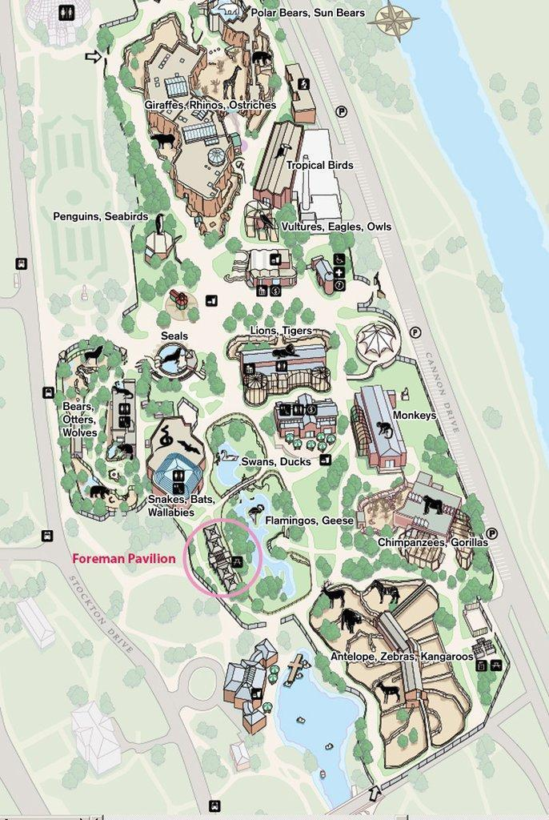

Virtual graph paper:
http://www.garrettbartley.com/graphpaper.html

Student Activity Sheet:
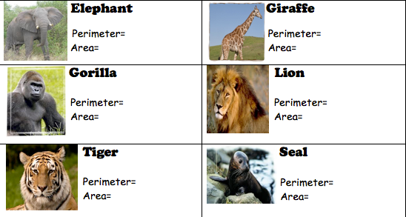

More resources for this lesson can be found at:
http://www.ashleykeine.com/stem-materials.html

Lesson Activities & Sequence:
Anticipatory Set:
Teacher will present this lesson by discussing real world application of what we have been learning about it math. Teacher will ask students to turn and talk about a job in the world that could use the skill of finding the area and perimeter of a particular space. Student responses will be collected and briefly discussed as a class. Teacher will then introduce the concept of someone designing the layout of a zoo, (if not already discussed in student responses).

Teacher Demonstration:
- Questions:
- Are all animal spaces in the zoo the same? Why not?
- Would an elephant and a spider need the same size or type of space? Why or why not?
- What do you need to consider when designing a space for your animal? (record student responses)
- Teacher will then demonstrate an example of creating a space for a penguin using information gather from research about a penguin’s habitat.
- Teacher will then demonstrate how to find the perimeter and area (showing work) of the space created.

Student Independent Work:
- Students will organize their information from their research on their animal including animal habitat, diet, behaviors, etc.
- Students will use a tablet to design a space for the animal considering their research using the virtual graphing paper: http://www.garrettbartley.com/graphpaper.html
- Students will find the perimeter and area of their space they created.

Proficiency:
Assessment:
- Rubric for self-assessment which includes:
  - Did I correctly identify the area of my space using units?
  - Did I show my work on how I found the perimeter of my space?
  - Did I correctly identify the perimeter of my scape using units?
  - Does my space accommodate my animal’s needs?
**Perimeter and area calculations must be 100% correct in order to be successful in next lessons. If students are struggling, allow time for peer edit/discussion or conferencing with the teacher. If spaces are created that are disproportionate to animal’s needs, this will be corrected in future lessons.

Teachers As Learners:
Teachers enjoyed this engaging lesson. It was crucial for them to know the position this lesson plays in the entire scope and sequence of the unit. The background knowledge was presented to them before the lesson began. Teachers liked the anticipatory set because it got their minds thinking in the lens of area and perimeter and applying it to real-world situations. Teachers were eager to work with the technology provided as the teacher modeled what they would be doing. There was a learning curve with the technology and using the virtual graph paper. Questions arose about erasing a line and how to change the size of the grid on the graph paper. These questions were easily addressed and did not affect the learning. Teachers enjoyed using the technology and came up with very different designs for their animal spaces. They were able to explain their design features as it pertained to their animal’s needs. Overall, the lesson had high engagement, was highly integrated with other content areas and challenged the teachers as learners to apply their knowledge to a real-world situation.

Elements of Pretty Good Practice:
This lesson included many different teaching and learning styles. The lesson began with an engaging discussion to get students thinking about real-world application of perimeter and area. Transitions from each section of the lesson were well-designed and seamless. The teacher modeled an example of the activity, allowing students to see the procedural steps and thinking behind the activity. The lesson incorporated hands-on technology using tablets that allowed students to easily play around with different designs without having to worry about erasing pencil marks and ruining their paper. The lesson incorporates science and social studies content while applying mathematics skills, giving students a well-rounded experience. Students had a very structured environment as they moved from one part of the lesson to the other. Students also were supplied a rubric for self-assessment, allowing students to take more ownership of their learning. The real-world application of this lesson drove everything. The lesson has been set-up nicely with previous lessons being taught, while further lessons give this application real-world meaning for students.

Modifications and Adaptations
- To help reinforce that perimeter is a length for those students who are struggling, allow students to use a geoboard with a piece of string to create a space. Then have students measure the piece of string as a single line.
- For struggling students, allow them to use attribute blocks when designing their space so they can spatially see where elements would go to accommodate their animal’s needs.
- For advance students, allow them to show their work for area not by counting but by using strategies of multiplication.
- Allow students to share their designed zoo space with an employee at the zoo. This would be a great ending to the unit that shows a true real-world application of content.

Questions Arisen
- How do I erase a line on the virtual graph paper? Press the undo button in the control box located in the lower right corner
- How do I change the size of the grid on the virtual graph paper? Click the scale button in the control box located in the lower right corner to change the grid size
- Can you use this virtual graph paper on any device? Yes, it is an online website, therefore as long as your device can access the Internet, you can use the virtual graph paper.
- What does the self-assessment time look like? Students use a rubric to help assess their space. Students may also pair up to help correct any miscalculations on the area and perimeter.

Peer Feedback
This lesson could easily be adapted to higher grade levels. Ideas that were suggested are:
- Scale factor lesson using higher mathematics applications
- Creating a house blueprint then constructing a model
- Creating a playground design

